Data types and literals

Data types

Data types are used to represent data in memory.
Data types are used to create space or allocate memory for data.
Data types are to represent different types of data in memory (Main Memory/RAM).

Python data types are classified into 2 categories
- Scalar Data types
- Collection Data types

Scalar Data types
These data types are used to represent single value in memory (OR) these data types allocate or reserve space for one value.

- int
- float
- complex
- bool
- NoneType
Collection Data types (OR) Data Structures
These data types are used to represent more than one value in memory. Python collections are classified into 3 categories.
- Sequences
- Sets
- Mappings

- Sequences
  - List
  - Tuple
  - Str
  - Range
  - Bytes
  - Bytearray
- Sets
  - Set
  - Frozenset
- Mapping
  - Dict

Python support 14 standard data types (scalar + collection)

int datatype

int data type is used to represent integer values or integer literal in memory.

What is integer value?
An integer is numeric value without decimal.
Example: whole numbers, even, odd, natural numbers,…

Variable
Variable is a named memory location which contain value
Variable is container which contains data/information/value
The value of variable can be changed.

How to create variable in python?
Variable is created in python by assigning value

variable-name=value

Python is dynamically typed programming language, there is no variable declaration.

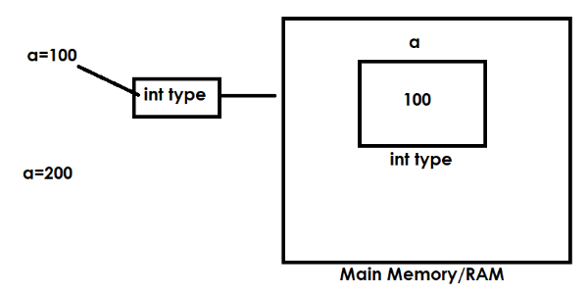

>>> a=100
>>> a
100
>>> b=200
>>> b
200
>>> c=a+b
>>> c
300

Python is derived or developed using features of the following programming languages,
- C (Procedural Oriented Programming)
- C++ (Object Oriented Programming)
- Modula-7 (Modular Programming)
- Perl (Scripting Language)

type()
type() is an in built-in function in python which returns type of variable.

Syntax: type(variable-name)

>>> x=10
>>> type(x)
<class 'int'>
>>> y=1.5
>>> type(y)
<class 'float'>

Python is an object oriented programming language.
In object oriented programming languages data is represented as objects and every data type is class.

The size of int data type in python is dynamic.

How to find size of variable or object?
“sys” module or library provides the function called getsizeof()
import sys
sys.getsizeof(variable-name)

>>> import sys
>>> sys.getsizeof(n1)
28
>>> n2=99999999
>>> sys.getsizeof(n2)
28
>>> n3=99999999999999999999999999
>>> sys.getsizeof(n3)
36
>>> n4=999999999999999999999999999999999999999999999999999999
>>> sys.getsizeof(n3)
36
>>> sys.getsizeof(n4)
48
>>> n5=9999999999999999999999999999999999999999999999999999999999999
>>> sys.getsizeof(n5)
52

In python integer values or literals represented in 4 formats
- Decimal Integer
- Octal Integer
- Hexadecimal Integer
- Binary Integer

Based on the base of the integer value it is classified into 4 categories or types. Base represents the number of digits used to construct number.

Decimal Integer
An integer value with base 10 is called decimal integer
This integer is created or constructed using digits range from 0-9
This integer value should not start with 0
Default representation is decimal format

>>> otp=44669
>>> type(otp)
<class 'int'>
>>> rollno=01234
SyntaxError: leading zeros in decimal integer literals are not permitted; use an 0o prefix for octal integers
>>> rollno=120
>>> type(rollno)
<class 'int'>
>>> n1=+45
>>> n1
45
>>> n2=-78
>>> n2
-78

Octal Integer
An integer value with base 8 is called octal integer
This integer value is constructed or created using digits range
from 0-7.
This integer value is prefix with 0o or 0O

>>> n1=0o45
>>> n1
37
>>> n2=0O67
>>> n2
55
>>> n3=0o78
SyntaxError: invalid digit '8' in octal literal
>>> n4=0o89
SyntaxError: invalid digit '8' in octal literal
>>> n5=0o921
SyntaxError: invalid digit '9' in octal literal

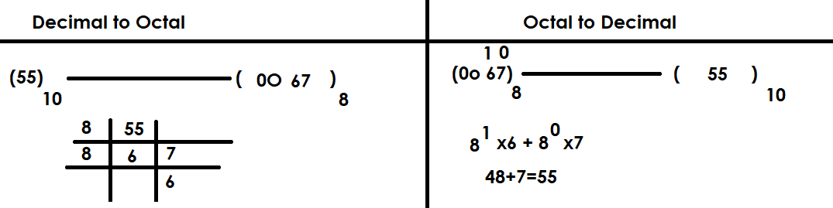

Applications of octal integer

codewithsatishgupta

